ESD-lab2

Name:Gan Ming ID: 192050221

1. Create a new project in the STM32CubeIDE software.

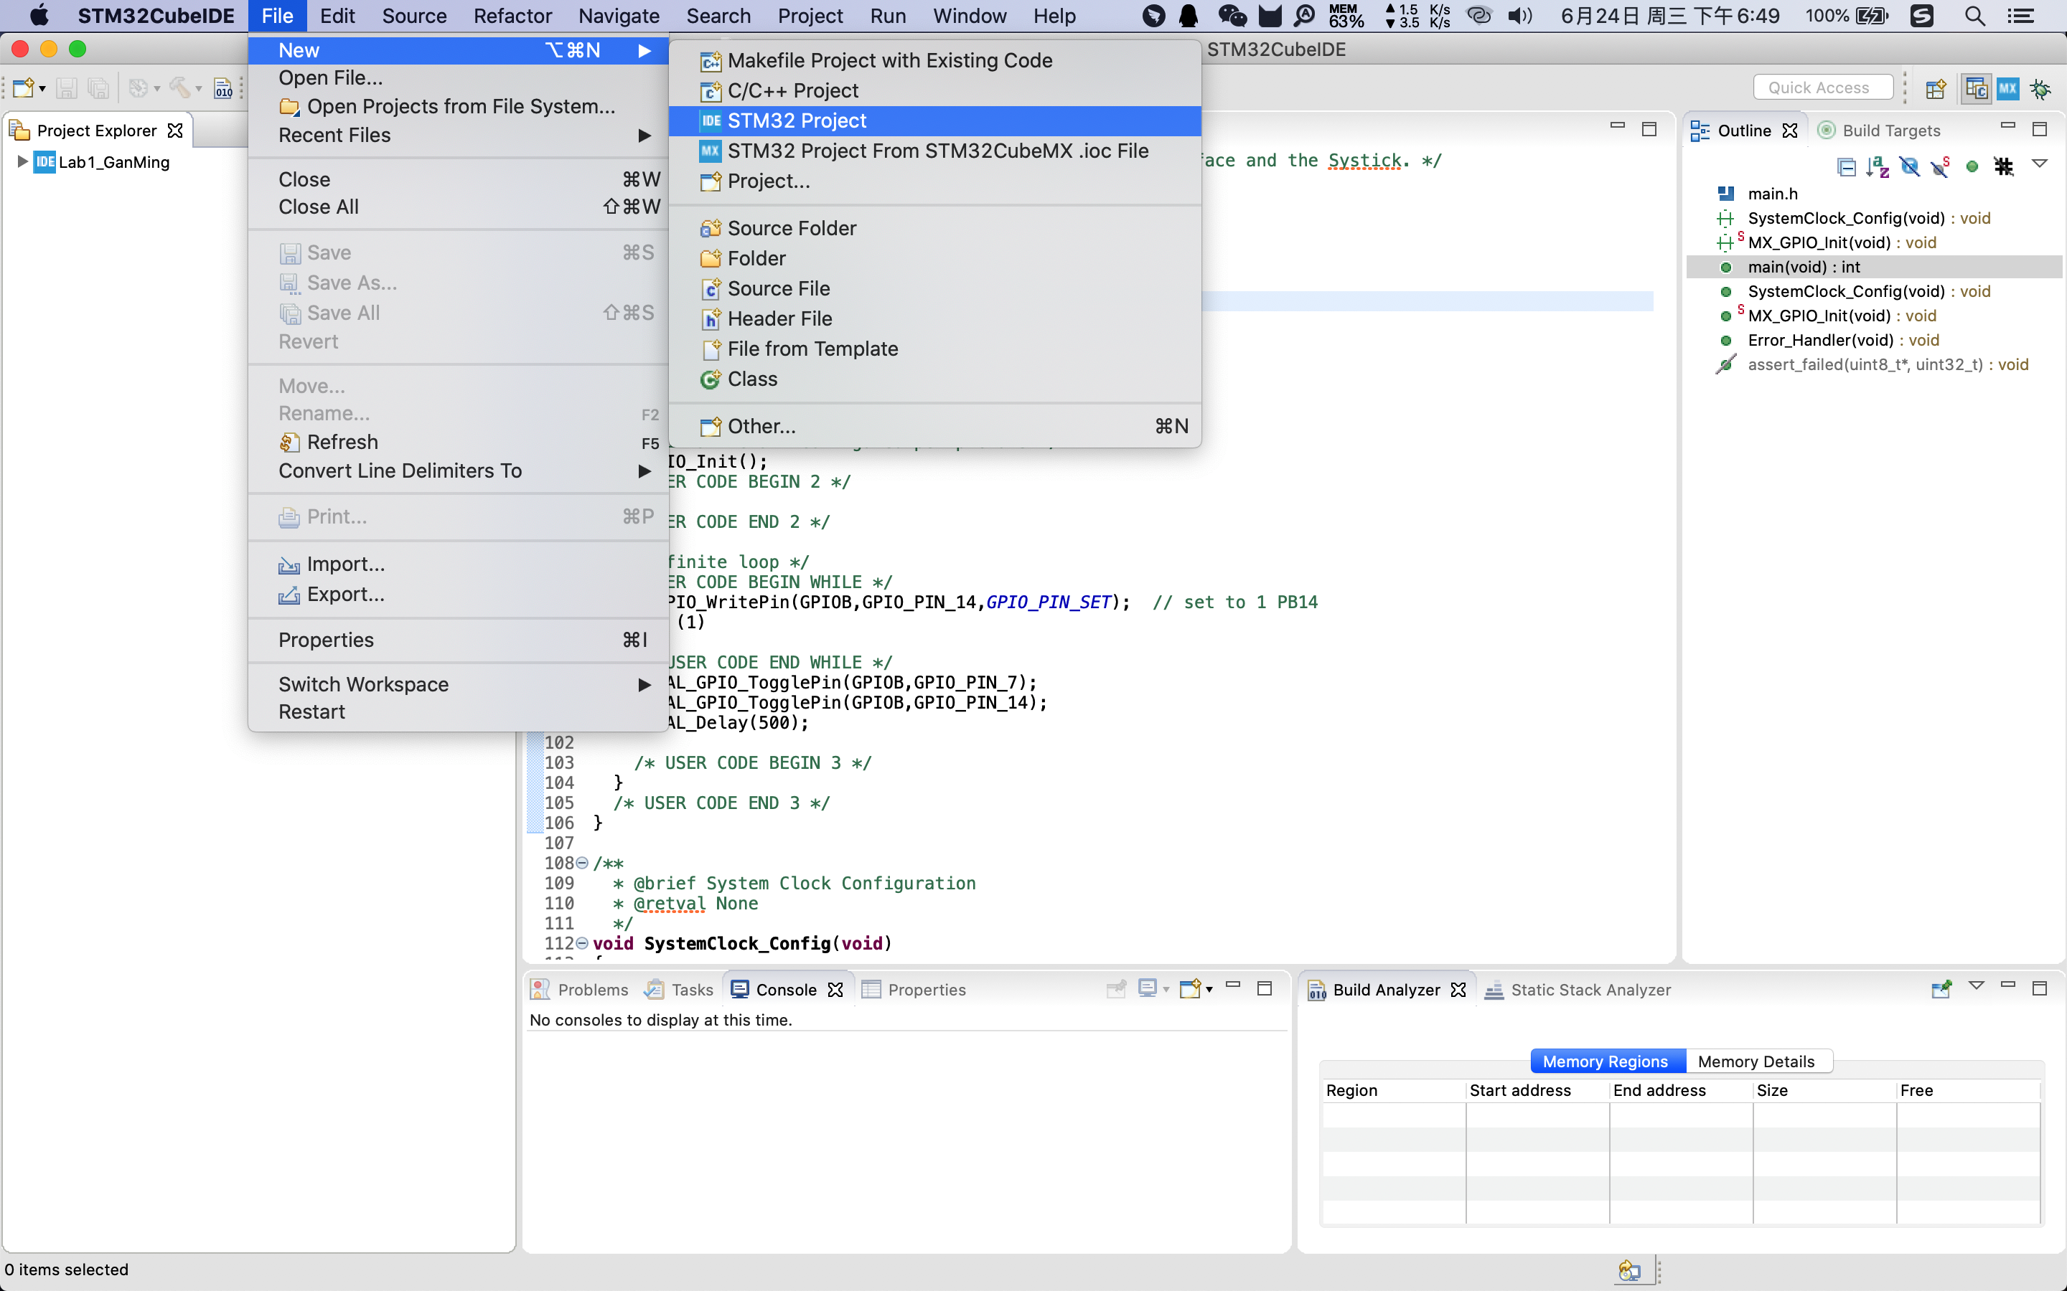

2. Find stm32F429zi to choose our board type,

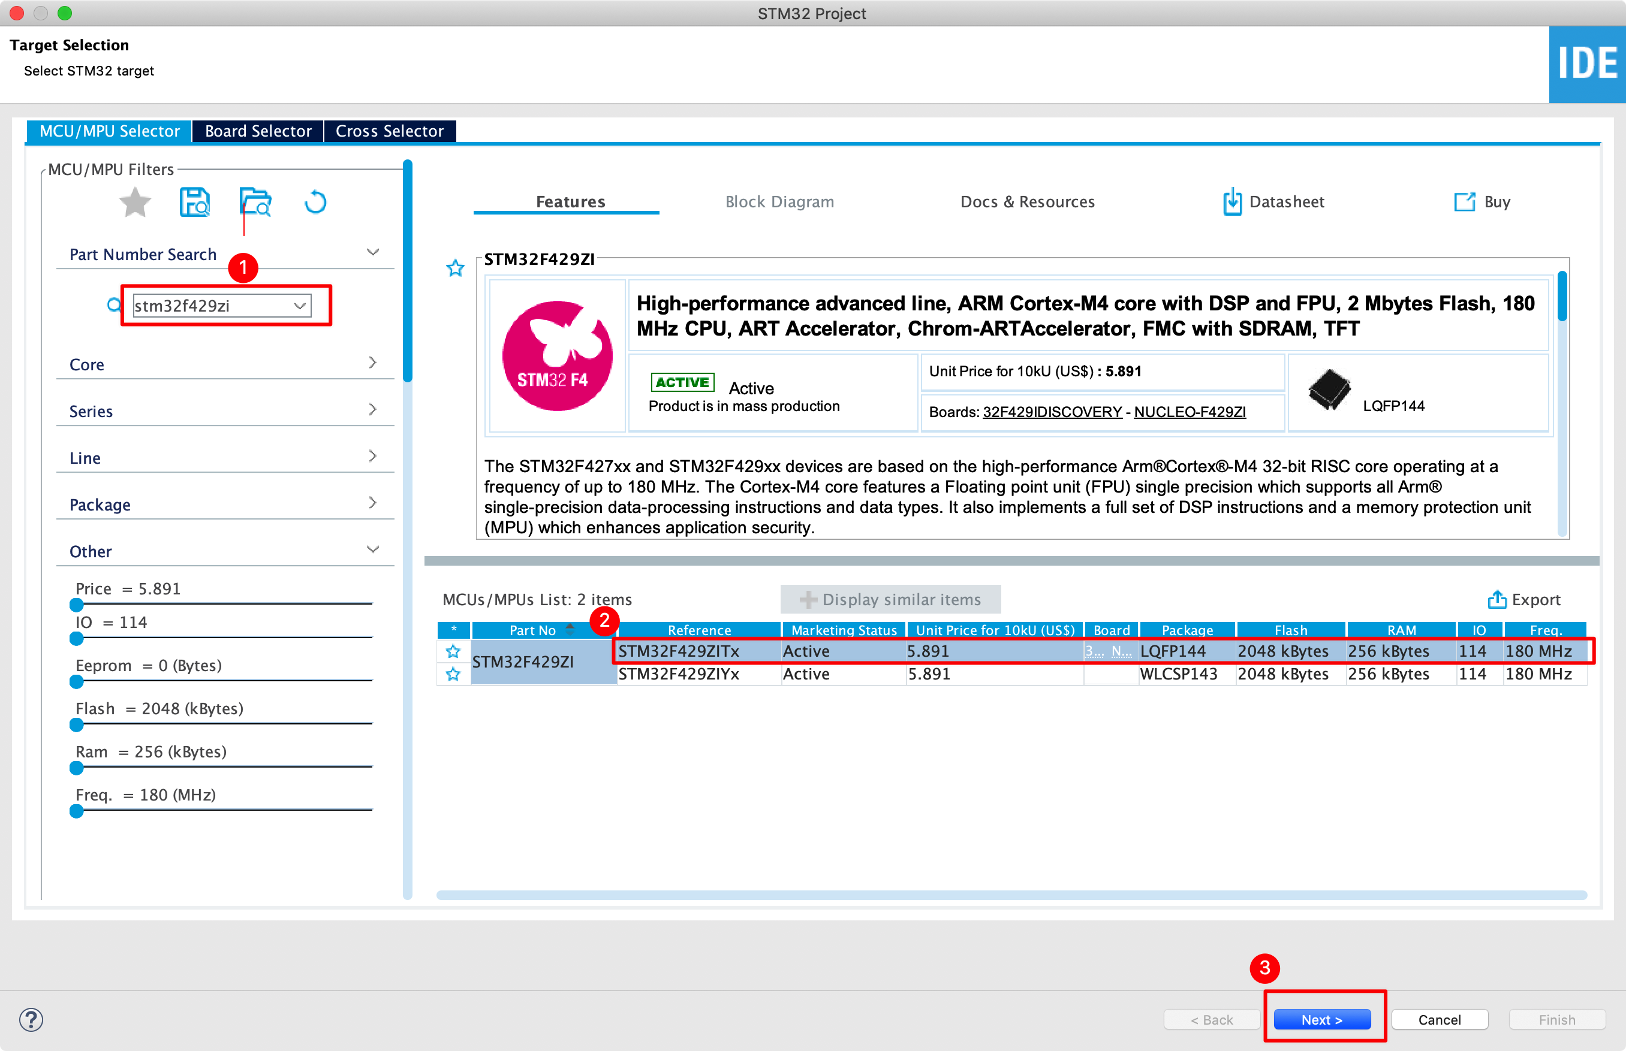

1. Take the project name, and automatically download the selected software packages.

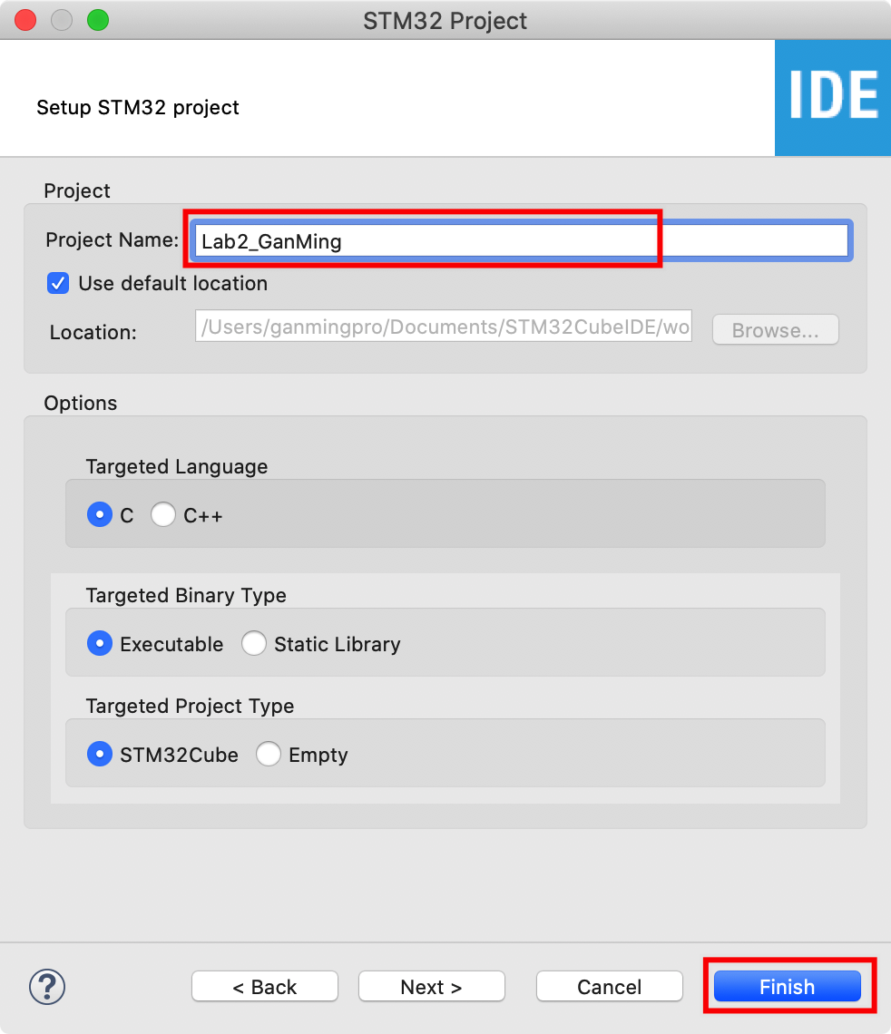

4. Query STM32 Nucleo-144 boards User manual to determine the functional pin of LD2 led, switch it to the output.

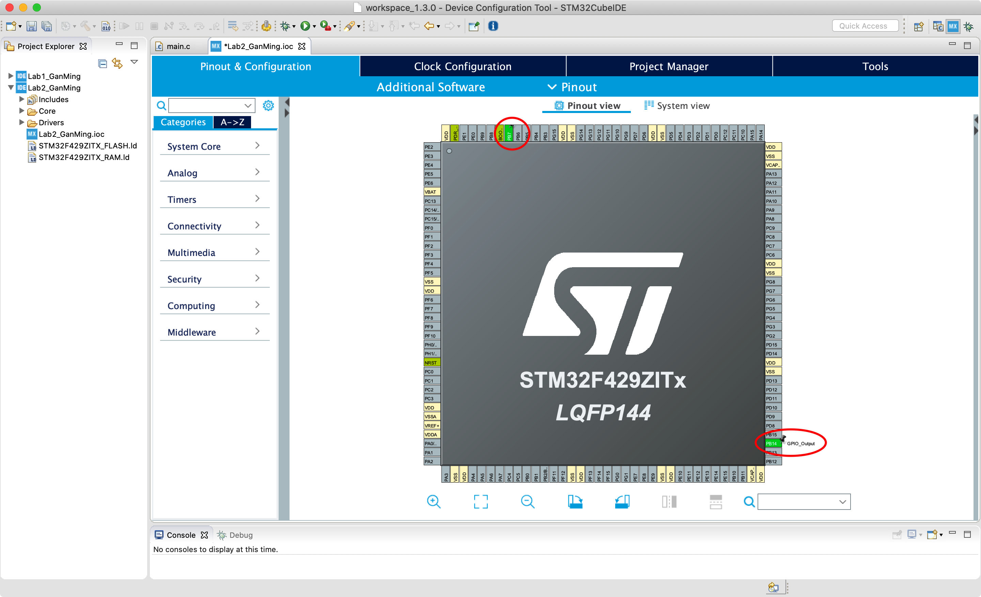

1. Create the first default task:DefaultTask.

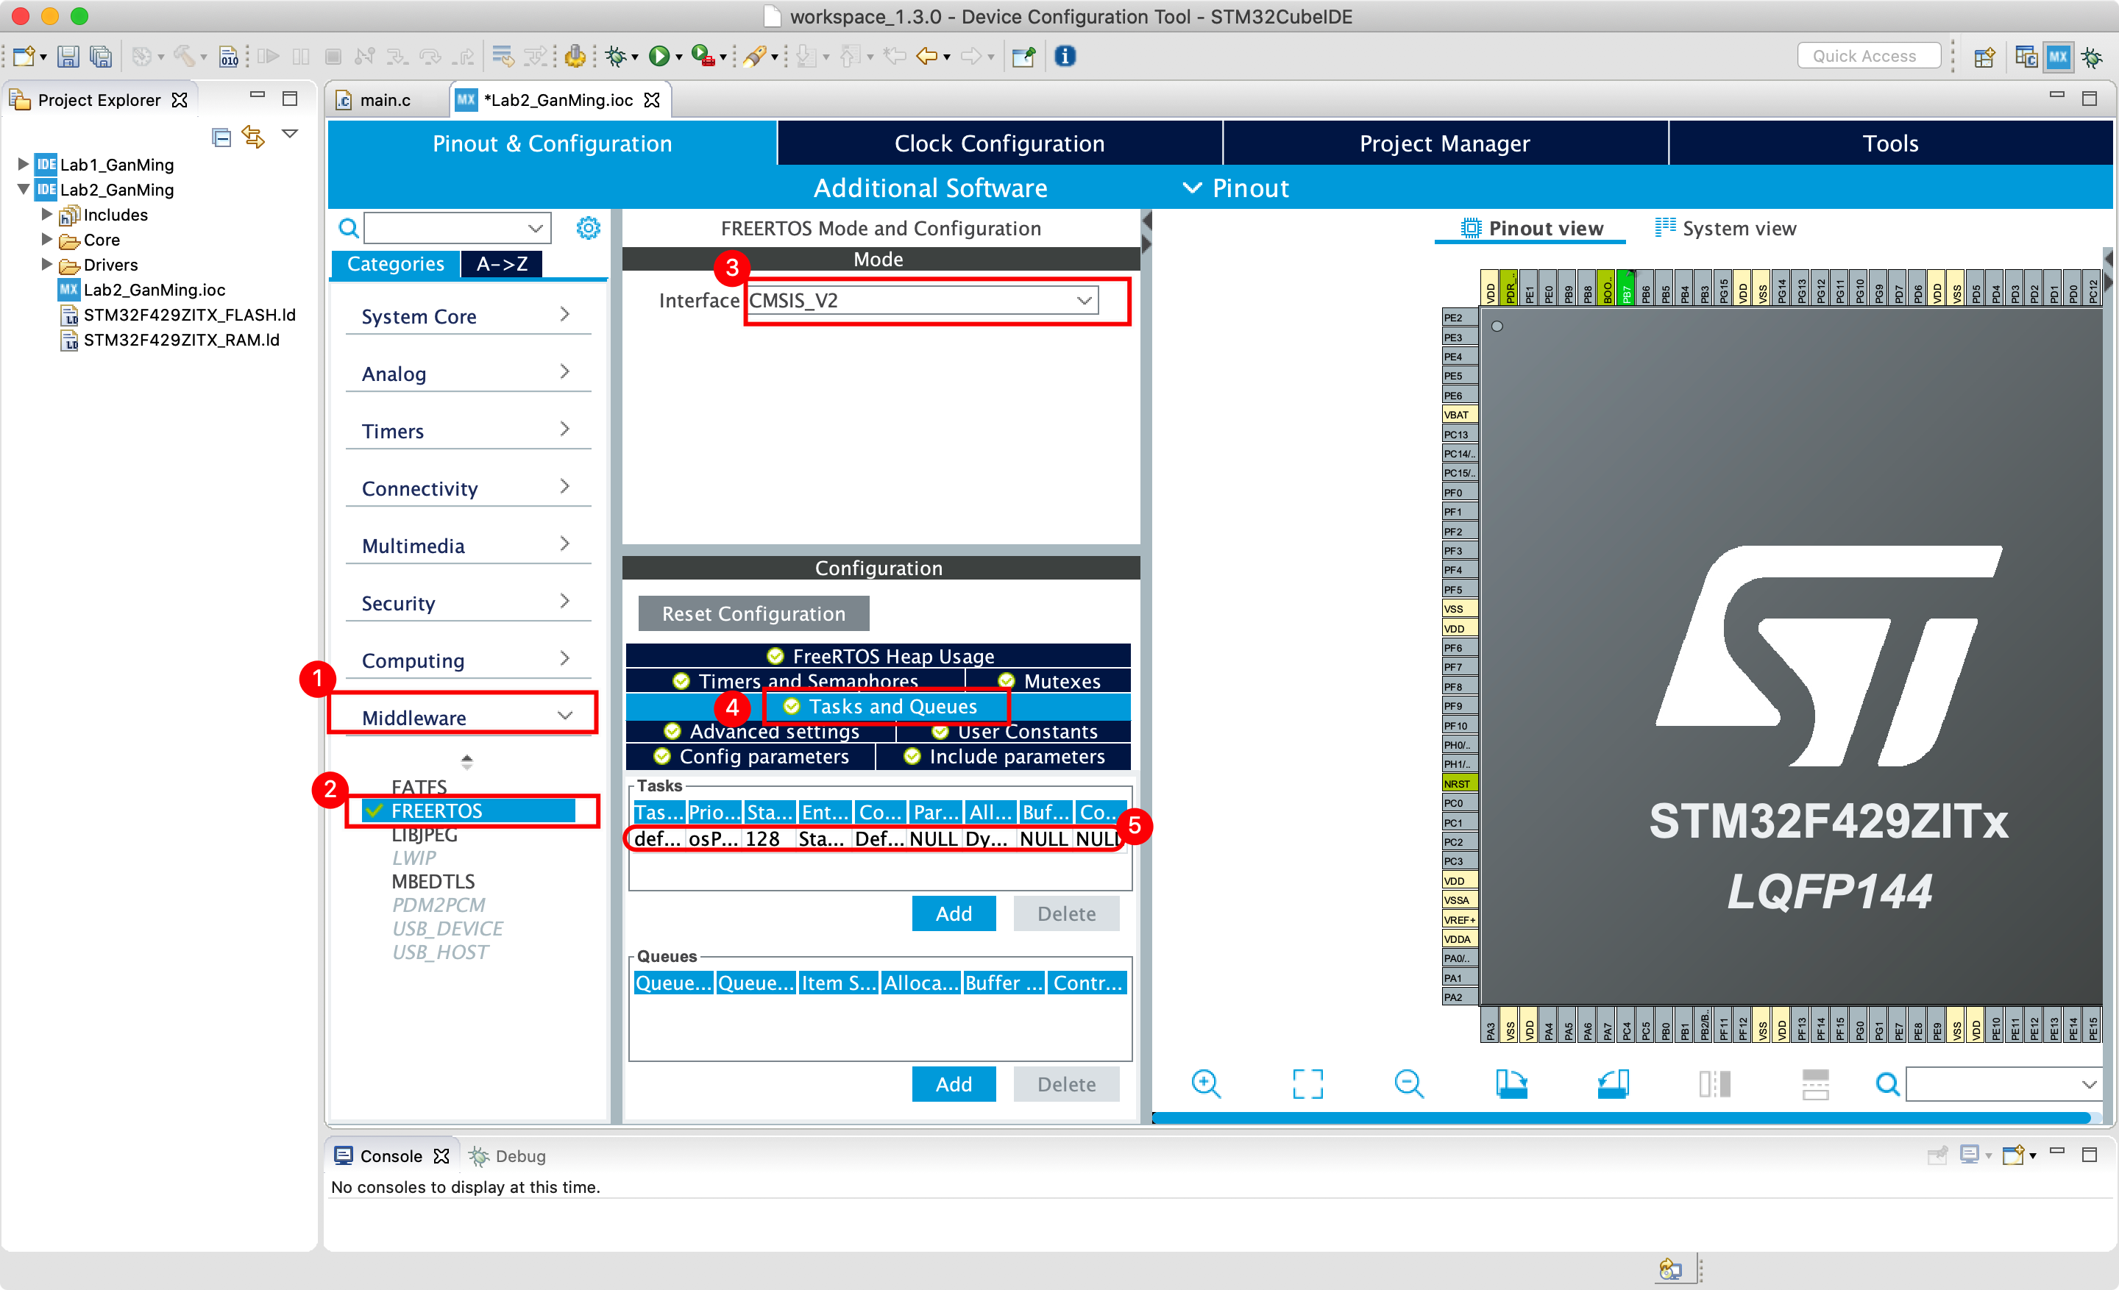

1. Add a second task:myTask02.

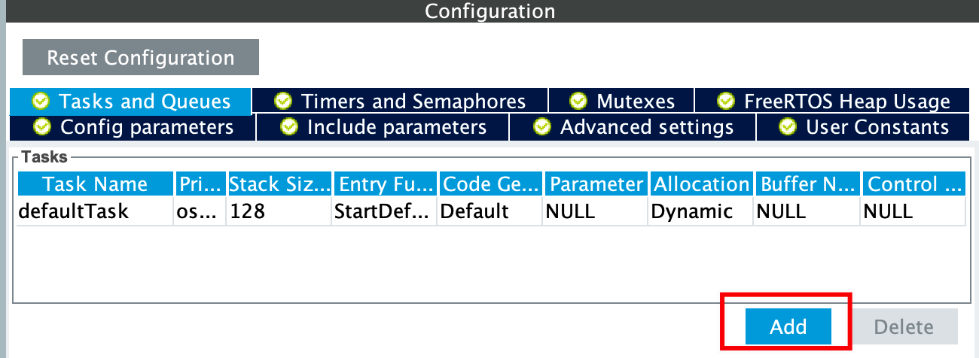

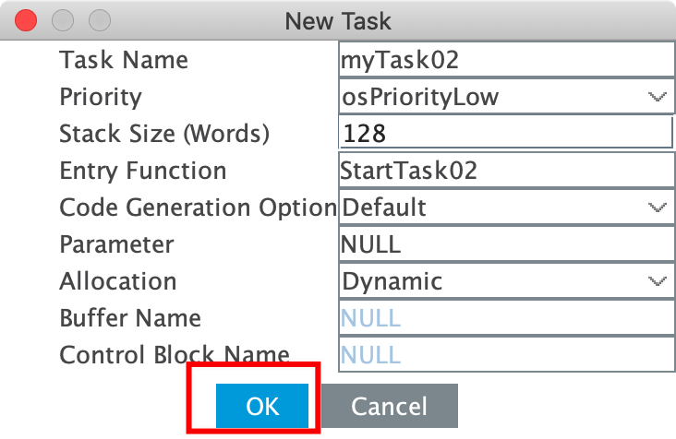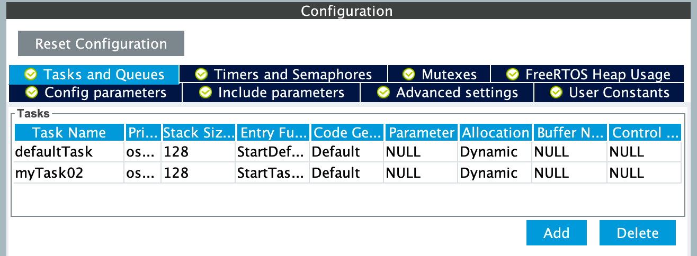

1. Build all to Generate the code.

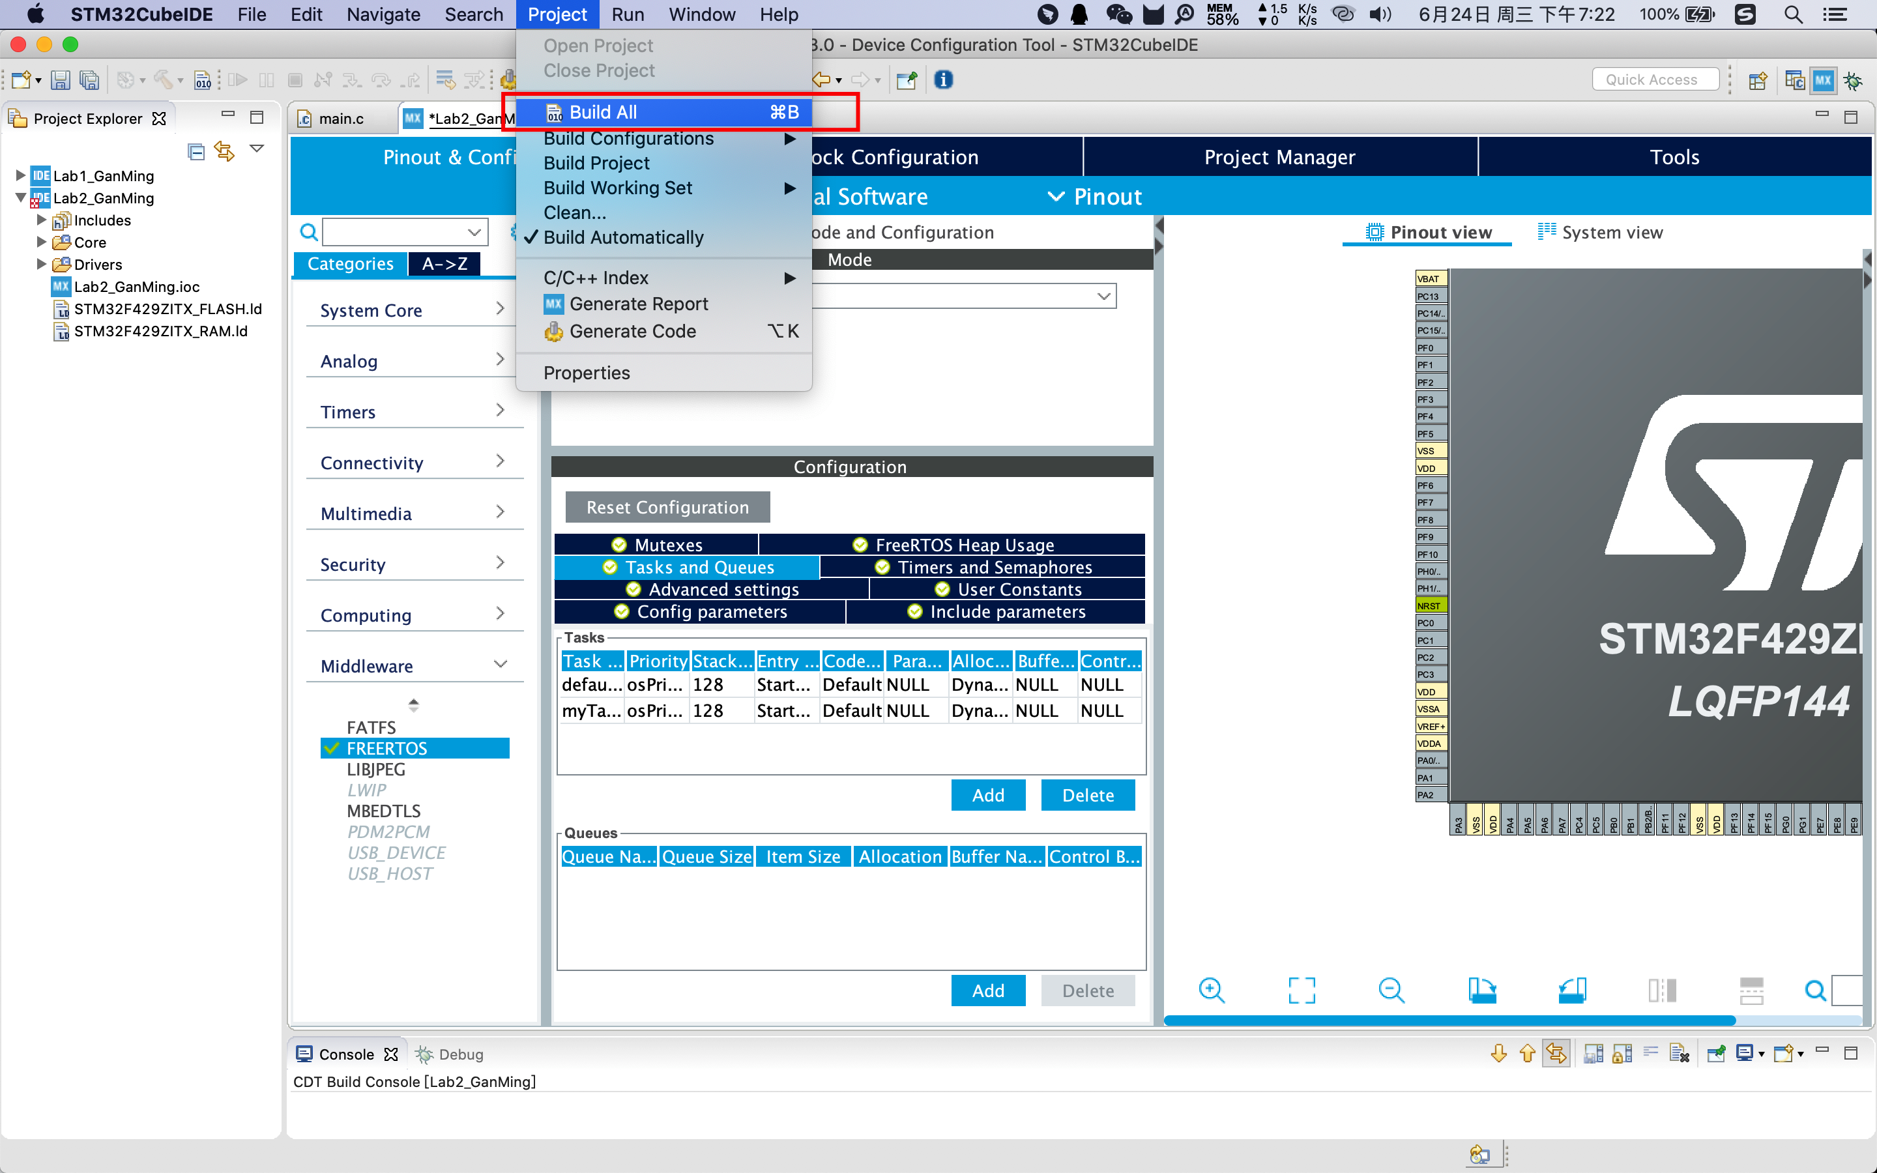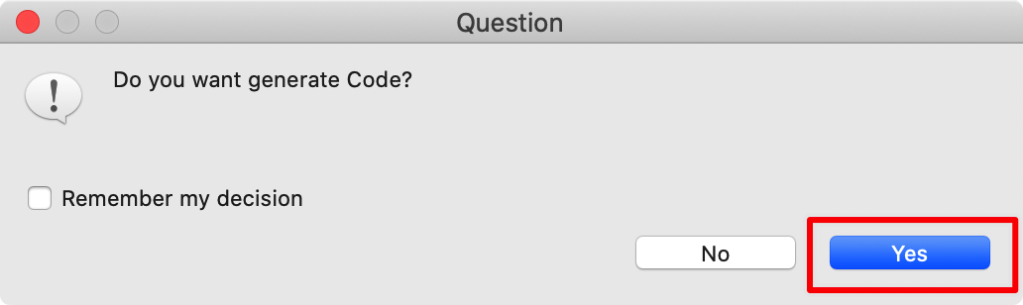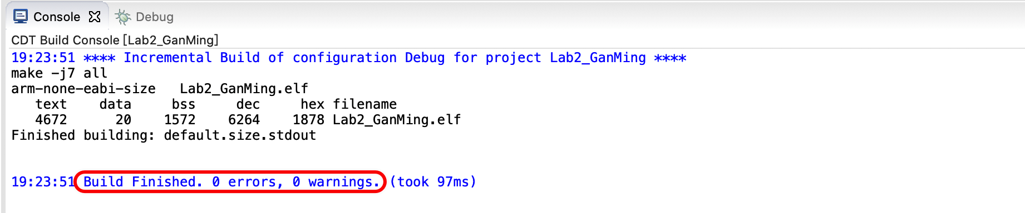

1. Insert the code to control the LEDs at different frequencies.

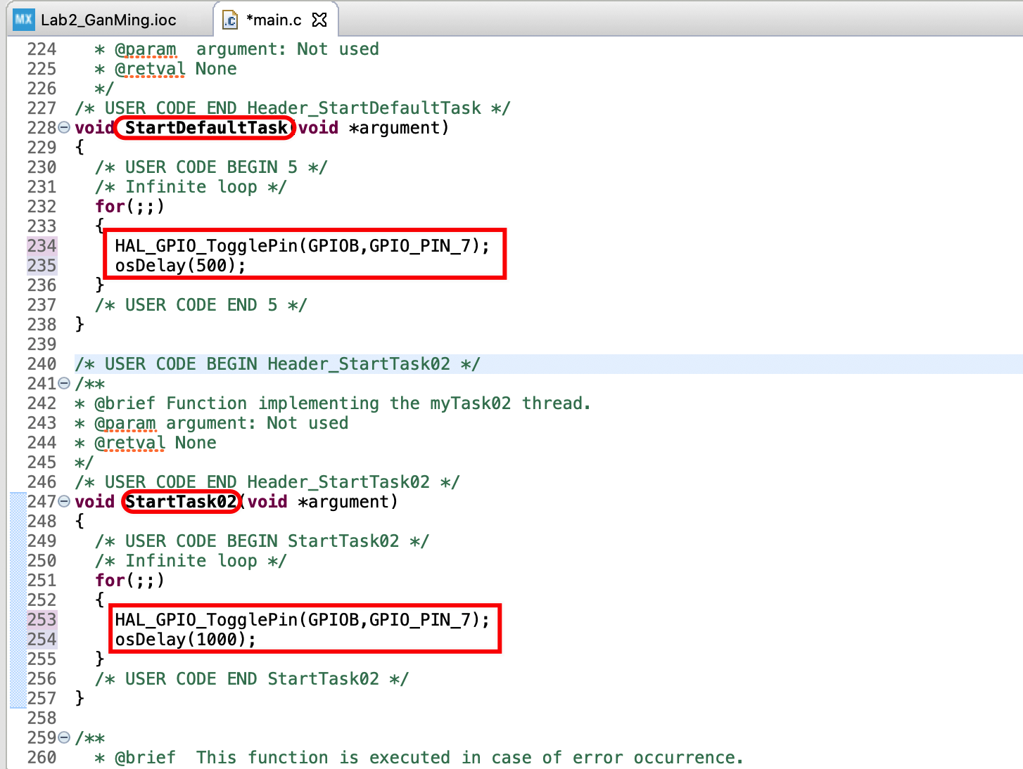

1. Then build the project again.

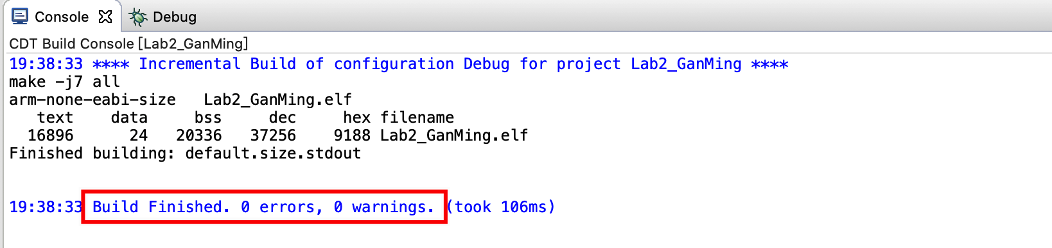

1. Run the project.

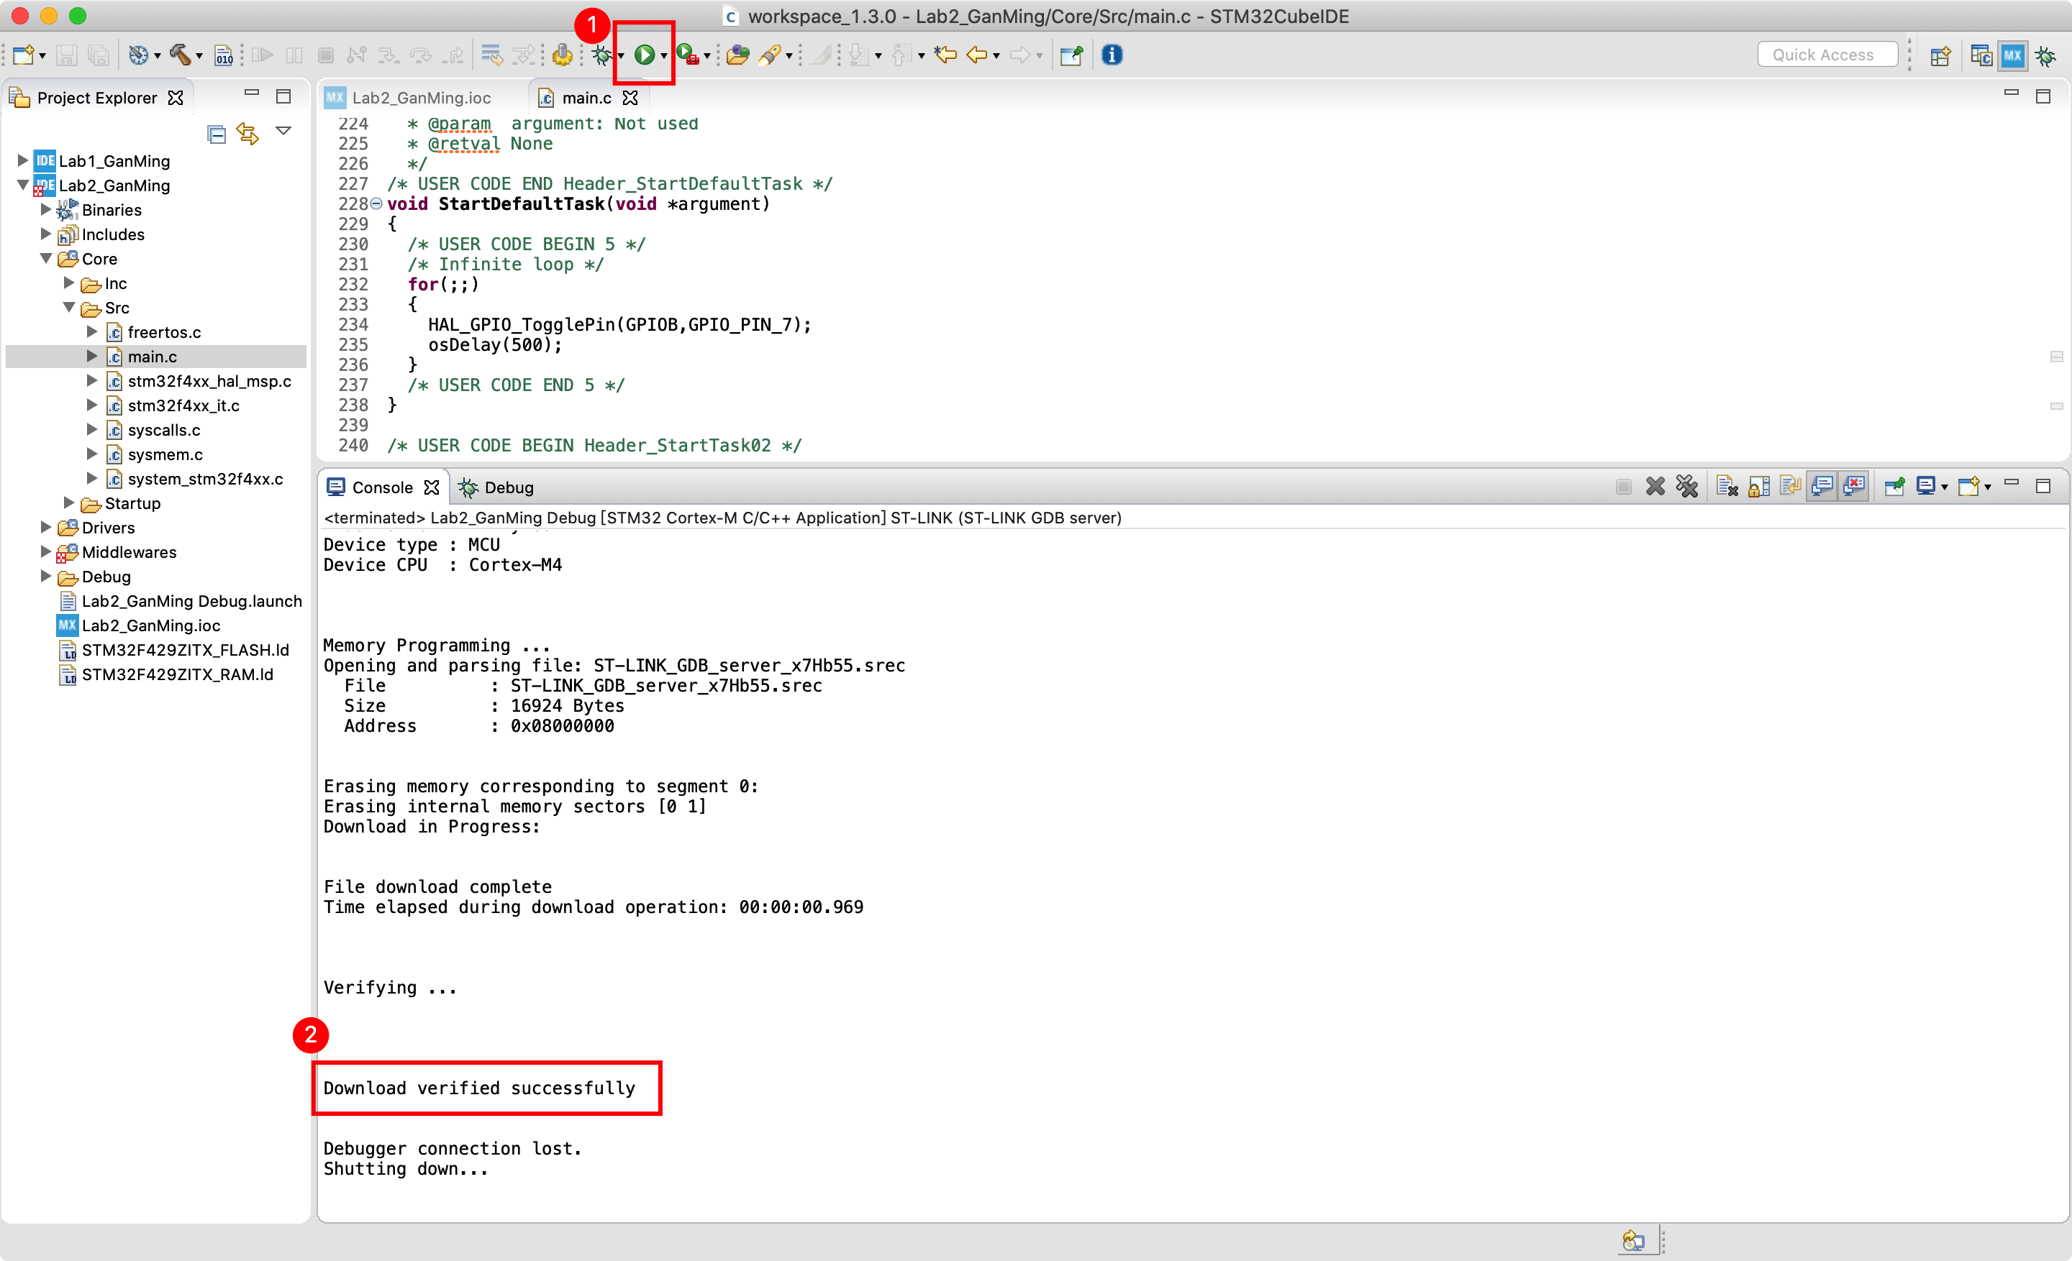

1. Experimental results video link:[Lab2\_GanMing\_Video.](https://www.icloud.com/iclouddrive/0tG33m66FGIz19U-WsYF4-FtA" \l "Lab2_GanMing_Video)

**Questions:**

1. **What features of FreeRTOS do you remember?**

(1) Support both preemption priority and collaboration priority;

(2) Very flexible task priority assignment;

(3) Flexible, fast and lightweight task notification mechanism;

(4) Queue;

(5) Count semaphore;

(6) Software timer;

1. **What are the differences between FreeRTOS, OpenRTOS and SafeRTOS?**

FreeRTOS and OpenRTOS share the same source code, but OpenRTOS puts FreeRTOS on ‘commercial and legal wrapper’’

There are two main reasons for users to update from FreeRTOS to OpenRTOS:

(1) In order to overcome the GPL license limitation of the modified version of FreeRTOS.

(2) In order to obtain additional services, such as professional technical support, high-quality middleware, training, consulting and corresponding tools.

SafeRTOS is also based on FreeRTOS, but unlike FreeRTOS, it has been redesigned by security experts.

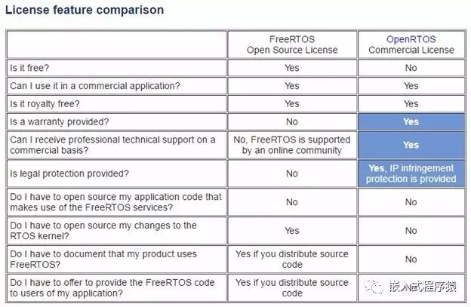

1. **Why do we need the vTaskStartScheduler() function?**

The function vTaskStartScheduler() is used to start the task scheduler and start scheduling tasks. FreeRTOS is started by the vTaskStartScheduler() function, which is usually encapsulated in osKernelStart(). Its work is as follows:

(1) xTaskCreate() creates idle tasks with the lowest priority: 0;

(2) Close the interrupt function and enable the task scheduling function;

(3) Macro definition portCONFIGURE\_TIMER\_FOR\_RUN\_TIME\_STATS: initialization of system runtime statistics;

(4) Set the system tick timer and start the first task;

(5) Return the idle task handle.

1. **Why do we need the xTaskCreate() function?**

As the name suggests, The xTaskCreate() function is to create the task.Create tasks from dynamically requested memory. Dynamically create a task, call the function internally to apply to the system for the memory needed to create a new task, including the task control block and stack. Therefore, when this function is called, in the case of insufficient memory heap space or fragmentation, it may fail to create a new task, and it is necessary to determine whether the function returns successfully after execution.